FACE_DETECTION

USING PYTHON

STEP 1 :

GitHub link: <https://github.com/adarsh1021/facedetection>

Open the github link has per given above click on the [haarcascade_frontalface_default.xml](https://github.com/adarsh1021/facedetection/blob/master/haarcascade_frontalface_default.xml) click on it.

STEP 2:

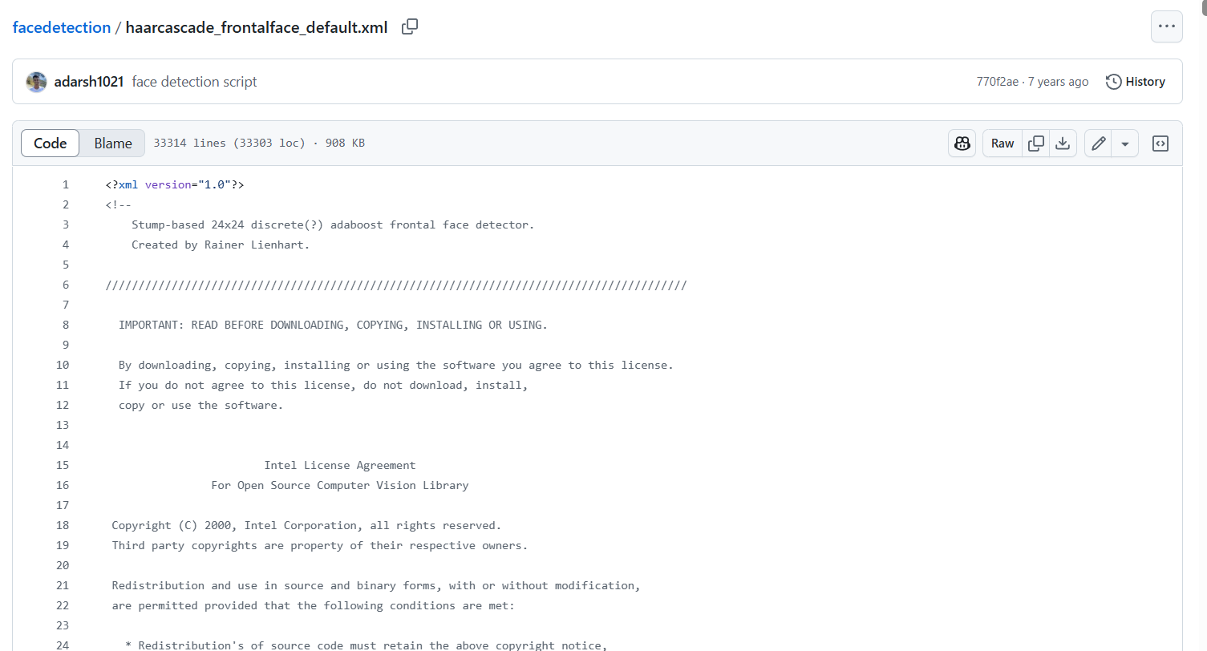

In the given image there is **Raw** click on it .

STEP 5 :

Create a folder name as face_detect .

STEP 4:

Raw is opened after saved the file as xml. In the folder of Face_detect.

STEP 5 :

Open in vs code and open the folder create file as face_detect.py .

STEP 6 :

Open the terminal in vs code itself.

INSTALL OPENCV

Cmd **: pip install opencv_python**

STEP 7:

Face_detect.py file enter the code has given below.

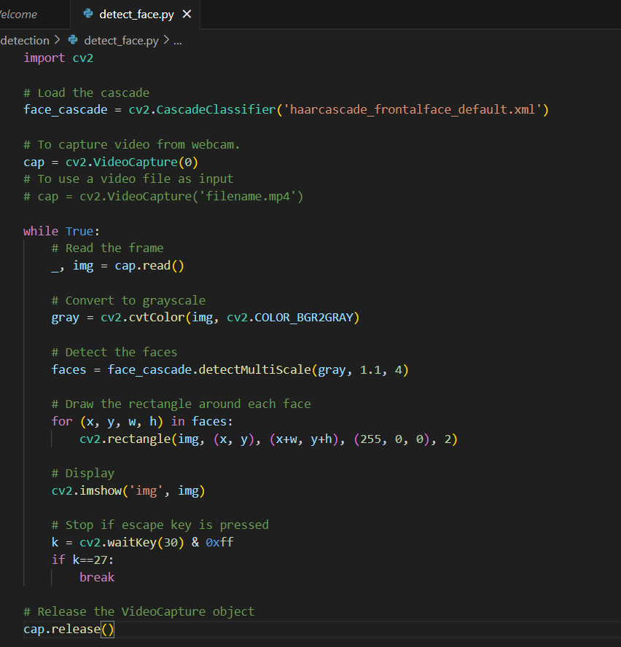

STEP 8 :

Open the terminal and enter given command

**Python face_detect.py**

**In face_detect.py you can write u r file as per u given the folder itself.**

**SIGN IN OFF :**

MARTHA KARTHEEK